27.03.2016

Uri Steinfeld & Tsvi Cherny

New Covertix Controls

Table of Contents

1. CxClassificationButton: 3

1.1 Necessary Properties: 3

1.2 Necessary Events: 4

2. CxClassificationButtonCollection: 4

2.1 Necessary Properties: 4

3. CxDialog: 5

3.1 Necessary Properties: 5

3.2 Necessary Events: 5

4. CxComboBox: 7

4.1 Necessary Properties: 7

4.2 Necessary Events: 7

5. CxComboBoxItem: 7

5.1 Necessary Properties: 7

6. CxRoundButton: 8

6.1 Necessary Properties: 8

6.2 Necessary Events: 8

7. CxListBox: 9

7.1 Necessary Properties: 9

7.2 Necessary Events: 9

8. 10

9. CxListBox Items: 10

9.1 Necessary Properties: 10

9.2 Necessary Events: 10

10. CxTextBox: 10

10.1 Necessary Properties: 10

11. CxObject List: 11

11.1 Necessary Properties: 11

11.2 Necessary Events: 11

# CxClassificationButton:

## Necessary Properties:

* 1. Color
  2. Height
  3. Width
  4. Selected
  5. Highlighted
  6. Tooltip
  7. Tag: like in C#
  8. Sort Index: This index will be used by the collection to show the collection of buttons in a sorted fashion.
  9. Drop Shadow

## Necessary Events:

* 1. Mouse Enter
  2. Mouse Leave
  3. Click
  4. Right Click
  5. Double Click



# CxClassificationButtonCollection:

## Necessary Properties:

* 1. Title: If no title is given than upper row shouldn’t be prompted.
  2. Background Color
  3. IsUseMore: Shown the More Button.
  4. SortBy: Could be by Button Index or by label (lexicographically)
  5. Drop Shadow



# CxDialog:

## Necessary Properties:

* 1. Title
  2. SizeStyle: Fixed, ResizableVertical, ResiableHorizontal, Resizable
  3. Icon
  4. IsShowTaskBar
  5. DialogResult
  6. DropShadow
  7. Drop Shadow

## Necessary Events:

* 1. OnLoad
  2. OnClose

* For our dialog: If it is open than we can stretch it only downwards when it only enlarges the list boxes.

** Is it possible to create some kind of general animation for that dialog?   
*** Separator only appears if both Icon and Title appear.

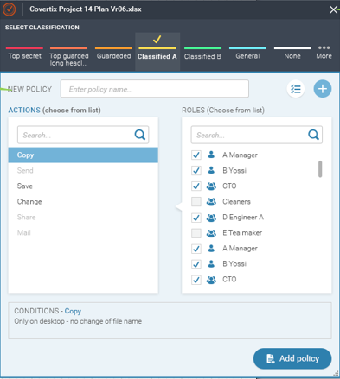

# **CxComboBox**:

## 4.1 Necessary Properties:

* 1. Style: Could be Round or Rectangular
  2. Readonly: If set to false than the user should be able to type inside.
  3. IsAutoComplete
  4. AutoCompleteList
  5. Selected
  6. Tag: like in C#
  7. Drop Shadow
  8. Arrow Color
  9. ComboBox Item Collection:

## 4.2 Necessary Events:

* 1. OnOpen
  2. OnSelectionChange: Gives old item and new item.







# **CxComboBoxItem**:

## Necessary Properties:

* 1. Label
  2. Tag
  3. Enabled
  4. Font
  5. Color
  6. Tag: like in C#
  7. Drop Shadow

# CxRoundButton:

## Necessary Properties:

* 1. Tooltip
  2. Tag
  3. Icon
  4. Background Color
  5. Foreground Color
  6. Label: *If label is empty than button should show as a circle. **If label is over fixedwidth it should show three dots.
  7. Drop Shadow
  8. IsToggle
  9. Checked
  10. Fixed Width

## Necessary Events:

* 1. Mouse Enter
  2. Mouse Leave
  3. Click





# **CxListBox**:

## Necessary Properties:

* 1. Selected
  2. Drop Shadow
  3. Height
  4. Width
  5. Label
  6. Selection Arrow Index: Two options for this property:
     1. If -1 Hides small arrow. If not -1 it is located at the given index. If the index is larger than the current size the arrow disappears and appears again if the user chooses to enlarge the list
     2. Always located in the middle.
  7. List Box Items

## Necessary Events:

1. OnSelectionChange: Gives old item and new item.

* Always auto completes by items labels.

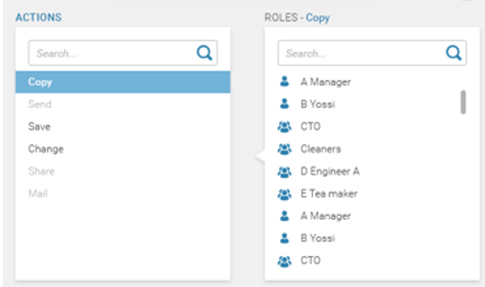

# CxListBox Items:

## Necessary Properties:

* 1. Tag
  2. Enabled
  3. Label
  4. Icon

## Necessary Events:

1. OnSelectionChange: Gives old item and new item.

# CxTextBox:

## Necessary Properties:

* 1. Shadow Text Label
  2. Width
  3. Height
  4. Auto Complete Collection
  5. Is Auto Complete



# CxObject List:

## Necessary Properties:

1. Title
2. CheckBox for All Items
3. Objectlist Items Collection
4. Tag

## Necessary Events:

1. OnSelectionChange: Gives old item and new item.

